NAMA: ________________________________KELAS: _______ Bahasa Indonesia

Yr 8: Viewing, Reading & Responding
Assessment 3, Term Three

Total mark:  32 | % | Weight  20%

My estimated score out of 32: ____________

Respond appropriately to each task given.

SECTION ONE: Label each of the direction images below with the appropriate Indonesian term.



(10 Marks)



______________________ ______________________ ______________________

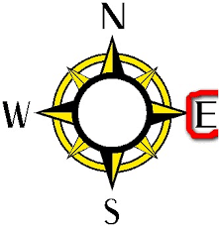

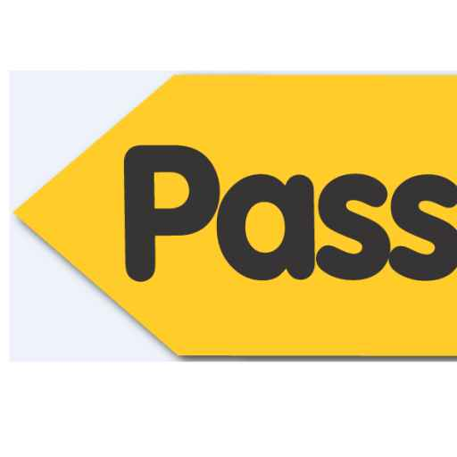

______________________ ______________________ ______________________

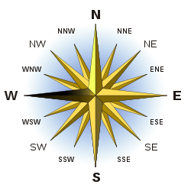


______________________ ______________________ ______________________



_____________________

SECTION TWO: Translate the directions into English.
(10 Marks)

1. Jalan terus.

____________________________________________________________________

2. Nomor dua belas.

____________________________________________________________________

3. Lalu lewat…...

____________________________________________________________________

4. Berhenti di depan…...

____________________________________________________________________

5. Jalan sampai…….

____________________________________________________________________

SECTION THREE: Translate the following sentences into Indonesian.
(12 Marks)

1. Start at number twenty.

____________________________________________________________________

2. Turn left.

____________________________________________________________________

3. Walk straight until…….

____________________________________________________________________

4. Then pass…...

____________________________________________________________________

5. Stop in front of…….

____________________________________________________________________

